Seminar Report

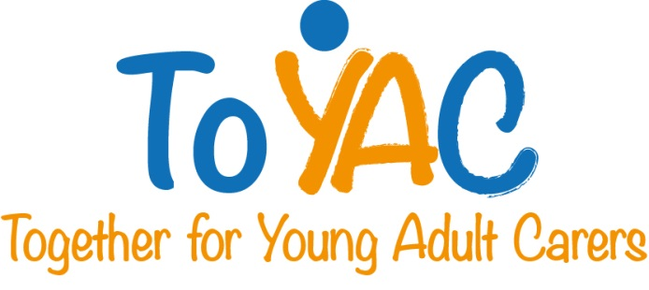

Young/Young Adult Carers in Ireland: A round table discussion with some informal presentations.

Tuesday 14th May, 10.00-16.00

MACRO Community Resource Centre,1 Green Street (off North King Street), Dublin 7, Ireland

Background

This seminar was organised by Care Alliance Ireland, one of 6 EU partners in the TOYAC Project.
(www.youngadultcarers.eu)

The format of the seminar was agreed with the 6 partners and specific efforts were made to involve key people in Ireland involved in supporting Children and Young Adult Carers. A copy of the invitation sent to 21 Irish participants, including the Background to TOYAC and the Seminar Programme is in Appendix I.

The objectives were to share experiences of the relevant work ongoing, to network, to provide encouragement and affirmation to providers and potential providers and to build the momentum in this field.

12 Irish people took part in the seminar (Appendix II) together with 10 people from the 5 other EU TOYAC partners. (Appendix III)

Presentations

After registration, welcomes and some short introductions a number of presentations were made on the following topics. The detailed presentations are embedded in this report.

- Young Carers in Ireland – What the Census 2011 Figures are saying; Liam O’Sullivan, Care Alliance Ireland

- Young Carers in Ireland – Outline of The Carers Association’s work with Young Carers – Gary Rutherford, Young Carers Outreach & Development Coordinator (Two presentations)

- Third Level Access Initiatives – How such initiatives can support access to, participation and retention in third level education with particular reference to Young Adult Carers. (John DeLap, Project Officer, Community Links at Dublin Institute of Technology)

(Lunch – in Local Restaurant)

- TOYAC European Partners –Summary of Findings from European partners.(Full and Summary Report – Final version following modifications made after the seminar)

- Young Carers Festival in Scotland – Video Input and Presentation (Lorna Goodwin, Carers Trust UK)

- Supporting Young Carers – the Youth Sector and Formal Education Sector working together in North Dublin, Sonnia Coughlan, City of Dublin Youth Service Board (Two presentations)

The presentations were followed by some discussion, clarification and reflection.

The seminar ended at 16:00hrs.

Evaluation/Feedback

The evaluation was completed by 14 participants. In summary the seminar fully met the expectations of 11 participants, whilst it partially met the expectations of three. Some suggested changes for future seminars included; have a shorter or in-house lunch, be more interactive, use a speed dating format for people to mix and have Young Adult Carers present.

Next Steps

This report and the presentations will be placed on the www.youngadultcarers.eu website.
The next seminar will take place in Utrecht 8th October 2013, hosted by Movisie.

Liam O’Sullivan
Care Alliance Ireland

September 2013.

Appendix I

Invitation to Irish Participants (Including Background, Objectives and Seminar Programme)

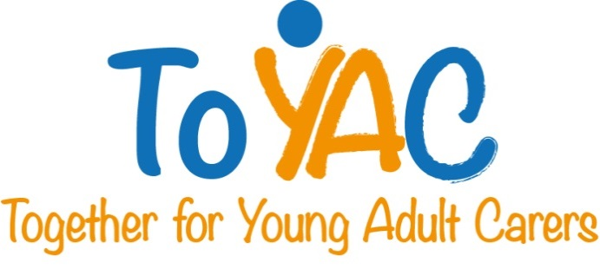
April 2013

We are delighted to invite you to an upcoming invitation only round table discussion/seminar hosted by Care Alliance Ireland.

Young/Young Adult Carers in Ireland: A round table discussion with some informal presentations.

Tuesday 14th May, 10.00-16.00
The Richmond Room, The Carmichael Centre, North Brunswick Street, Dublin 7.

Please scroll down to view the draft seminar programme.

Please RSVP by e-mail (info@carealliance.ie) by Tuesday 7th May. If you are not available to attend, I would be most grateful if you would nominate a colleague to attend on your behalf. The Carmichael Centre is just off Church Street, near Smithfield http://www.carmichaelcentre.ie/Location

We look forward to welcoming you to our seminar.

Yours sincerely

___________________
Liam O’Sullivan
Executive Director
Care Alliance Ireland

Background to this Seminar
Care Alliance Ireland is working with 5 European organisations on TOYAC, Together for Young Adult Carers. TOYAC is a partnership project funded by the European Commission and is focused on the development of strategies and services for young and adult carers. Many of these young carers are vulnerable, and have limited opportunities, horizons, and aspirations. Because of their caregiving responsibilities, many underperform in school and are at high risk of exclusion from the labour market. On the other hand, it has been demonstrated that caring develops knowledge, understanding, sense of responsibility, maturity and a range of life, social and care-related skills in children and young adults.
The TOYAC partners will meet for the first time at this seminar in Dublin and are keen to hear about the issues facing young carers and young adult in Ireland to-day. For further details of the project and the partners involved see http://www.youngadultcarers.eu
Care Alliance Ireland, has undertaken some preliminary investigation around the impact caring has on young adult carers’ participation in third level education. Other project partners have taken on detailed investigation in their own countries on other specific aspects of young adult caring. These focus specifically in the area of siblings with disabilities, interventions by condition-specific NGOs, the role of youth services, the possibilities of social networking for supports, and young carers in employment. A summary of the findings will be presented at the seminar. Our European colleagues are also keen to meet with those in Ireland who are currently working with young carers and or have an interest in the area.
Draft Programme

10:00 Registration/Informal Networking – with Tea/Coffee and Scones

10:30: Welcome and Brief Introductions

10:45: Young Carers in Ireland – What the Census 2011 Figures are saying; Liam O’Sullivan, Care Alliance Ireland

11:00: Young Carers in Ireland – Outline of The Carers Association’s work with Young Carers – Gary Rutherford, Young Carers Outreach & Development Coordinator

11.45: Third Level Access Initiatives – How such initiatives can support access to, participation and retention in third level education with particular reference to Young Adult Carers. (Speaker to be Advised)

12:15: Discussion

12:45: Lunch (in local restaurant)

14:00:TOYAC European Partners –Summary of Findings from European partners.

14:45: Some key messages from conversations with Third Level Access Officers; Liam O’Sullivan, Care Alliance.

15:15: Supporting Young Carers – the Youth Sector and Formal Education Sector working together in North Dublin, Speaker to be confirmed

15:45: Discussion
16:00: Finish

Appendix II

Irish Attendees at TOYAC Seminar – May 14th 2013

Liam O’Sullivan Care Alliance Ireland
Nora Kirrane Crosscare Carer Support
Grainne Peers Crosscare Care Support
Gary Rutherford The Carers Association
Ann Flynn The Carers Association
James Doorley National Youth Council of Ireland
John DeLap Dublin Institute of Technology - Access Officer
Daragh Kennedy Irish Wheelchair Association
Jill Barrett Dublin Institute of Technology – Careers Advisory Officer
Sonnia Coughlan City of Dublin Youth Service Board
Jennifer Kavanagh City of Dublin Youth Service Board

Appendix III

European Attendees at TOYAC Seminar – May 14th 2013

Hanneli Döhner (DE) | wir pflegen
Matthias Wirtz (DE) | wir pflegen
Barbara Leonardi (IT) | ASP
Eloise Righi (IT) | ASP
Licia Boccaletti (IT) | ANS
Serena D’Angelo (IT) | ANS
Jolanda Elferink | MOVISIE
Ilse de Bruijn | MOVISIE
Lorna Goodwin | PRTC
Louise Morgan | PRTC

